
The blue and yellow represent Legacy Pointe's colors, and the green (growing higher) represents the continuing growth provided by our residents.
By Jonathan Wahl

May 2024

Our Day Begins – Here Comes the Sun

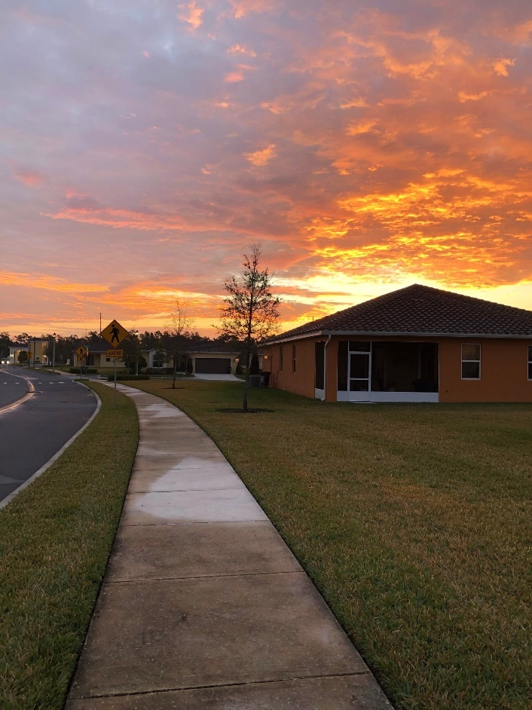
Photo by Marsha Call

OUR FEATURE ARTICLE ON MEMORIAL DAY



This year our Memorial Day service will span two days and will include a new commemoration – the inauguration of our new Flag and flagpole.

Our Veterans Group is well into planning for this year's Memorial Day activities. Here's a reminder to SAVE THE DATE, Monday, May 27 at 10am in the Auditorium. We will honor our fallen service members and pay tribute to the sacrifices they made for our country. The Auditorium doors will open at 9:30am. (You must be in your seats before 10 AM).

In addition, there will be a solemn "Missing Man Table" ceremony on Friday, May 24 at 4pm in the Auditorium. We look forward to your joining us..

Parkinson Walk



Picture by Vicki Tindall

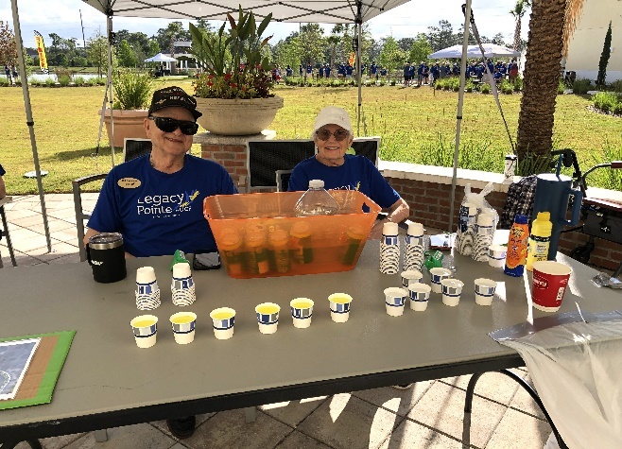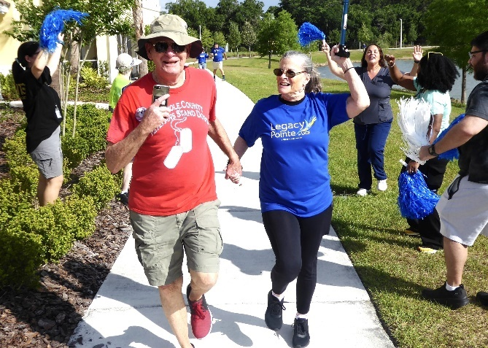

We are almost to the finish line and the cold lemonade will taste great!
Picture by Marsha Call Picture by Tom Nixon

Some events take years to plan, some take months, some take weeks. With all that planning some events fail.

Not at Legacy Pointe. The Parkinson Walk took days to plan and was a huge success based on the number of people participating and the amount of money raised. Don and Anita Ford put out the call and a few days later dozens of people gathered in the card room. Anita gave a presentation about the walk for Parkinson.
After her presentation it was decided we would do our own walk at Legacy Pointe. There followed a little discussion about how and where we could do the walk as well as who and what was needed. Then the volunteers present did what volunteers do – they planned the whole thing in one-night, organized groups to do every task and set what they thought would be an unreachable goal of $5,000.



Nancy Did It! Photo by Vicki Tindall Determination Photo by Vicki Tindall

It's official! The first ever Legacy Pointe at UCF Community Walk was an uplifting event and we had a wonderful time.

Thank you so much for joining together as a community to show support for people with Parkinson's. We raised a total of $10,440 for the Parkinson's Foundation to improve care and advance research towards a cure for the disease. This is more than double the goal we had set when we started planning this event.

With your help, we demonstrated that Legacy Pointe is a caring, supportive community that unites with purpose and accomplishes amazing things. Together, we Charge On!

With gratitude for your generosity and caring spirit, Anita.

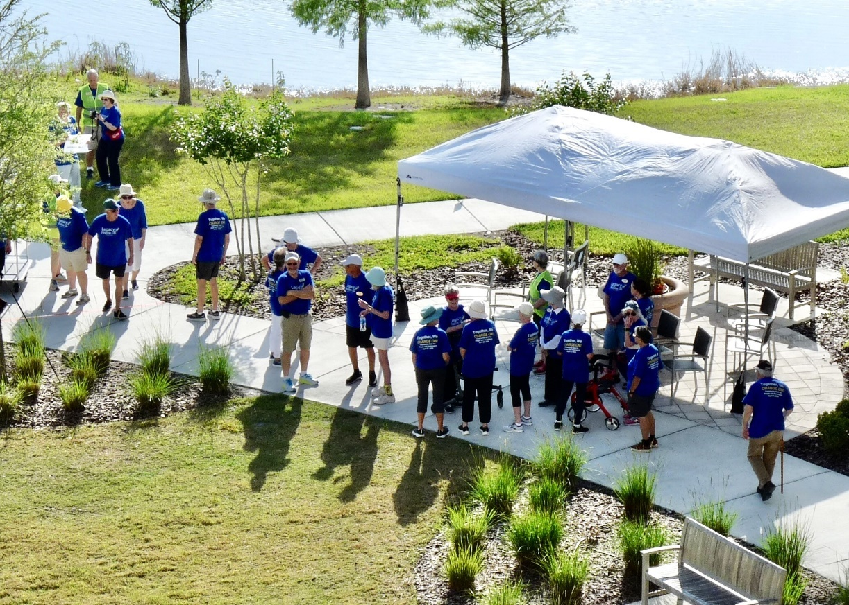

Roof Top View by Tom Nixon

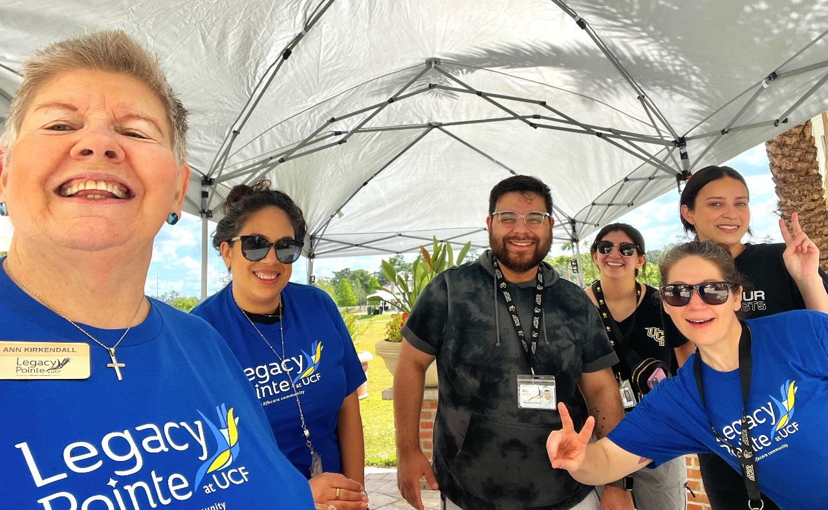

Moments of fun during Walk by Ann Kirkendall
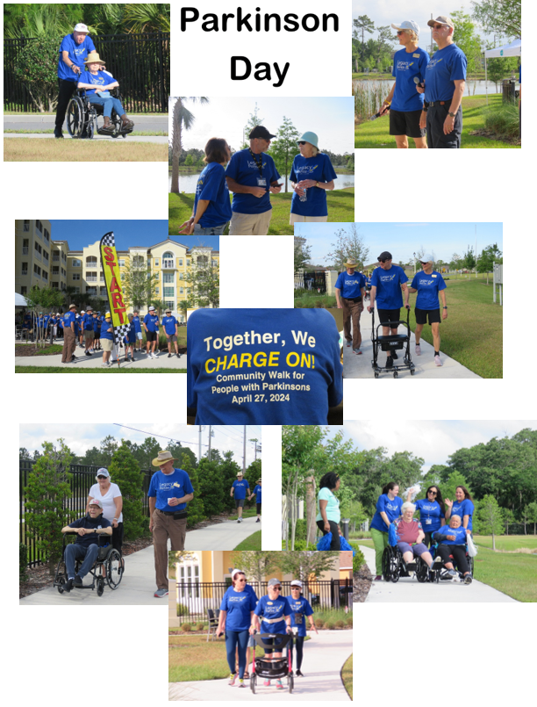

Collage by Mary Catherine Ricks

EARTH DAY IS REALLY 365 DAYS

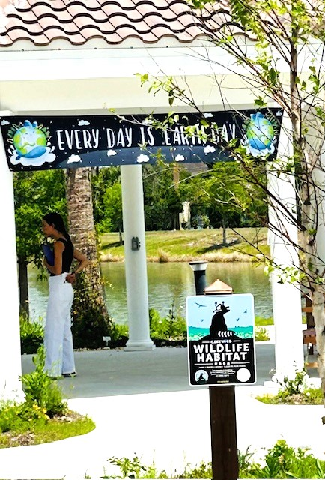

Photo By Maureen Reed

We enjoyed all the different ‘Earth Day’ events, especially the information tables where we were well informed about the threats that our planet is under and the butterfly garden where we learned about the Monarch Butterfly and other butterflies, hummingbirds, etc.

So, to keep Earth Day alive throughout 2024, the Legacy Pointe Independent Times will bring you monthly reminders about what you can do to make our planet bright blue and our air free from pollutants.

For the month of May, we will talk about this year’s Earth Day theme “Planet vs Plastics”. We are a community of senior residents living at Legacy Pointe. What can we do?

Lets start with what is already happening in our community:

- We can recycle – Aluminum Cans – we saw the L.P. Kan, Kan dancers showing how they crushed them. So, save all your aluminum cans and bring them to the trash room on each floor where there is a container for therm.
- We can recycle - Cardboard – Do Not throw it down the trash bin it will jam everything up. Pile it in the trash room. Please make sure all cardboard is clean, especially pizza boxes.
- Do not throw your batteries or electronics in the trash, we will talk about what to do with these, next month.
- Look for this symbol:


Styrofoam, Yes, we can recycle these cups, plates, dining room and bistro containers Look for the number 6 on these containers. Save them and bring them to Publix where they can be placed in the Styrofoam bin. There are dozens of residents going to Publix each week and if you cannot get there, someone will take your recyclables.

The theme for Earth Day 2024, is “Planet vs. Plastics”.

Plastics and Recycling by Frank Russo

We are starting to hear a lot about “Plastics” The threat is described in hundreds of scholarly papers, thousands of articles on the web and specials on TV. Recently investigative journalists have turned up the heat on the chemical and oil companies. These companies have known about the dangers of plastic both the possible pollution with nanoplastics and the problem of trying to recycle plastic. They have been involved in a campaign of possible cover-up.
And we have heard it all before. We all are old enough to remember the chemical companies trying to defend the use of DDT as harmless – until Rachael Carson and her book, the Silent Spring, came along. Then we had the cigarette companies for years running commercials and ads in journals, newspapers, magazines, billboards, etc. about the pleasures of smoking. Remember the doctor smoking, to relax after a hard day. Oh! and there was the Marlboro Man smoking out in the fresh air. What could be better!

Again, playing on the ‘age card’ remember President Dwight D. Eisenhower in part of his farewell speech. He spoke about the dangers of the emerging military industrial complex. The Second World War and the Korean War had brought Industry and the Military together which relationship produced a powerful lobbying group. Now throughout the world each country, large or small, has this lobbying group as well as many others.

In the past business groups have lobbying political groups whose purpose is to protect them. And again, that is what is happening with the chemical and oil companies.

In future editions of the Legacy Pointe Independent Times, we will be following the stories about the oil and chemical companies and what they knew about plastics.
The Link below is one example of what journalists are starting to report on what the oil and chemical companies knew. Does it sound familiar?

https://abc13.com/plastic-waste-crisis-in-united-states-percentage-of-plastics-actually-Everhgetting-recycled-recycling-statistics/14774625/
(hold the control key and click on the link or copy it and paste it into your browser).

It’s Springtime


Photos by Vicki Tindall

RECENT NEWS AND EVENTS
The Legacy Point Choir

On Thursday April 25th the Legacy Point Choir made its debut under the direction of Sue Brown. Twenty residents had practiced for weeks. The evening included songs and music from long ago (the 1930s, 1940s, 1950s).

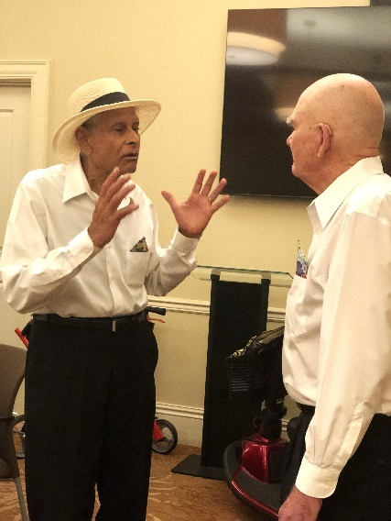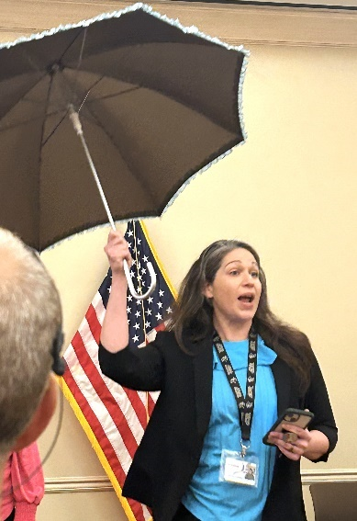
Victor and Mitch trying to clarify some of the action in “Take Me Out to The Ballgame”that goes with the music before the presentation.
And
Kristina Ferry in the presentation of “Singing in the Rain.”
Photo by Marsha Call Photo by Tom Nixon

Everyone in the audience knew every one of the tunes and felt free to join in with the choir. There were moments of comedy with the song “Take me out to the ballgame” and a comedy skit that went with it staring members of the choir and our Executive Director, David Kremer. Another whimsical presentation was “Signing in the Rain” staring our Life Styles Director Kristina Ferry.
Sue Brown, the choir director, did a solo “Somewhere over the Rainbow” which is a ballad by Harold Arlen with lyrics by Yip Harburg.[1] It was written for the 1939 film The Wizard of Oz, in which it was sung by actress Judy Garland[2] in her starring role as Dorothy Gale.[1] It won the Academy Award for Best Original Song and became Garland's signature song.
Pianist Carolyn Hoglin was recognized for her many hours accompanying the choir in their many practices.

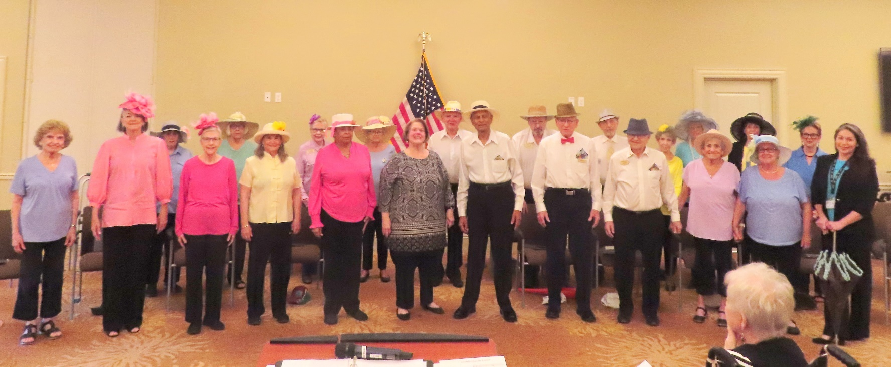
Photo by Vicki Tindall

The Legacy Pointe Regatta


Photo by Vicki Tindall

The third annual Legacy Pointe at UCF invitational regatta was held on 28 August 2024 on Edward’s Pond. This regatta was comprised of 11 Dragon Force 65 radio-controlled sailboats, six sailors from the Oviedo RC Sailors and five from the LP Drifters sailing clubs. Practice and boat trimming ran from 10:30 to 11:00 AM and race heats started at around 11. This year’s regatta consisted of eight heats with the Oviedo club winning both of the 2 First Place trophies, one for A+ sails and one for A sails, second place for class A sails also went to the Oviedo club. The regatta is being run during the Kentucky Derby week prior to the Derby. Next year’s regatta will award 1st, 2nd and 3rd place trophies and consist of A class sails only. The Legacy Pointe sailors are Frank Armetta, Ray Blake, Dick Huff, Tony Mennella, Edward North, Les Tandler and Dennis Wood. If anyone is interested in joining the Legacy Pointe club, you can contact any of the current members for information.

The Dragon Force 65 boat is the most popular RC sailboat worldwide with somewhere between 30,000 and 40,000 sold. The cost of a complete kit with radio and receiver, sails and everything to start sailing currently costing $315.00. Entry level boats come with class A sails only, but three additional sail sizes are available for different wind conditions. The overall boat length is 26 inches and 53 inches tall, keel to tip of the mast. Various decals are available to personalize your boat and make it easier to identify when sailing. The global DF 65 regatta is being held in Sweden this month and runs 5 days in length and a $325 dollar entry fee. The winner will be the World Champion and by the way the US National champion is a member of the Oviedo club.



A Lost Boat ?? by Vicki Tindall Still a close race by Vicki Tindall

Our New Fence

The new fence encircles the entire property. It is meant to keep everybody and everything out of our space. But in picture two below, someone did not get the message.

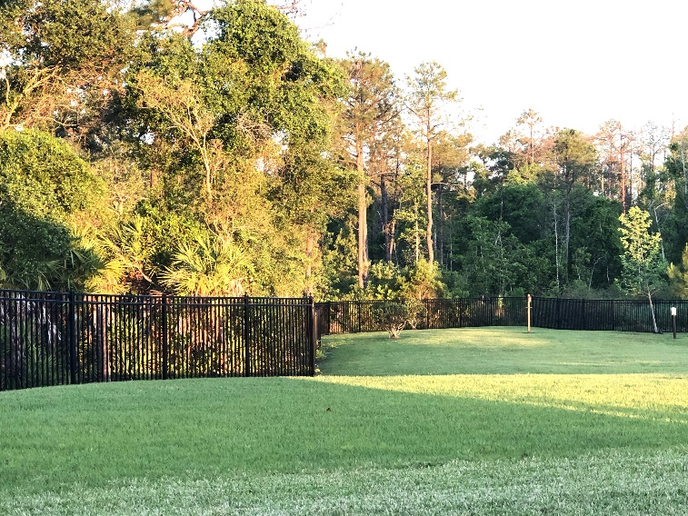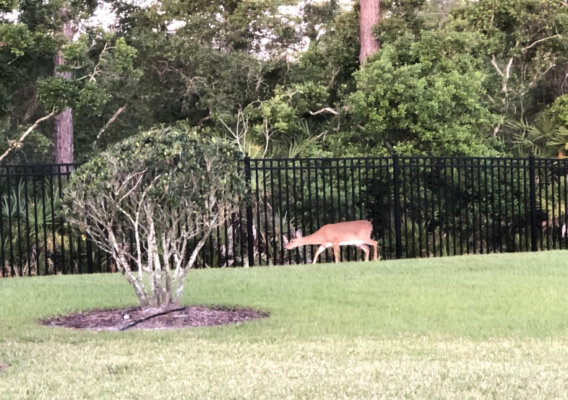
Photos by Marsha Call

Kentucky Derby Week

A day is not enough to celebrate a classic like the Kentucky Derby. At Legacy Pointe it took almost a week to let the festivities play out. The festivities started with the announcement banner on the wall outside the gym along with the credenza decorations, then the Ladies Tea and finally the race day events.

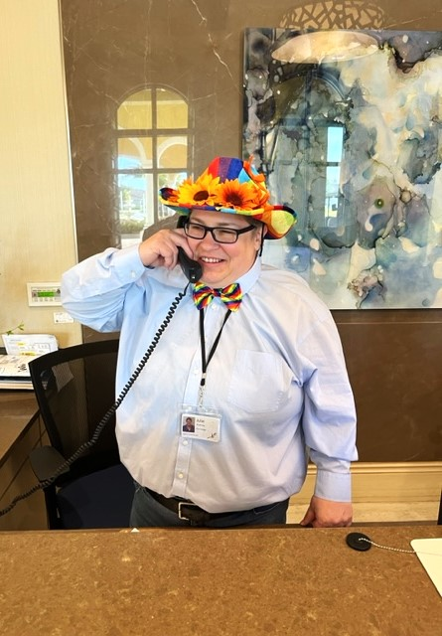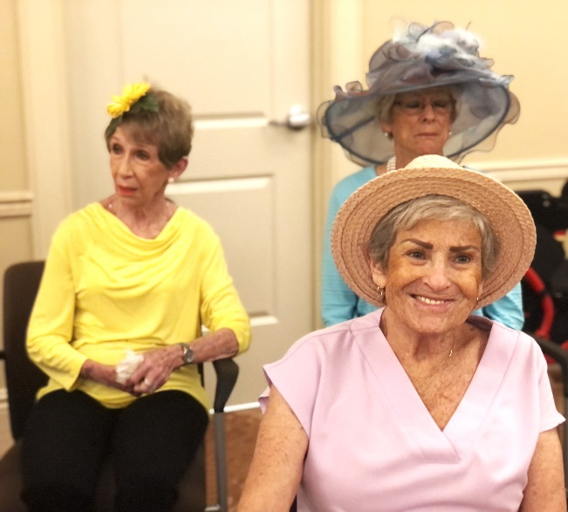

Everybody is getting ready for the Kentucky Derby.
At Legacy Pointe the celebration starts early
Photo by Dona Hams Photo by Marsha Call

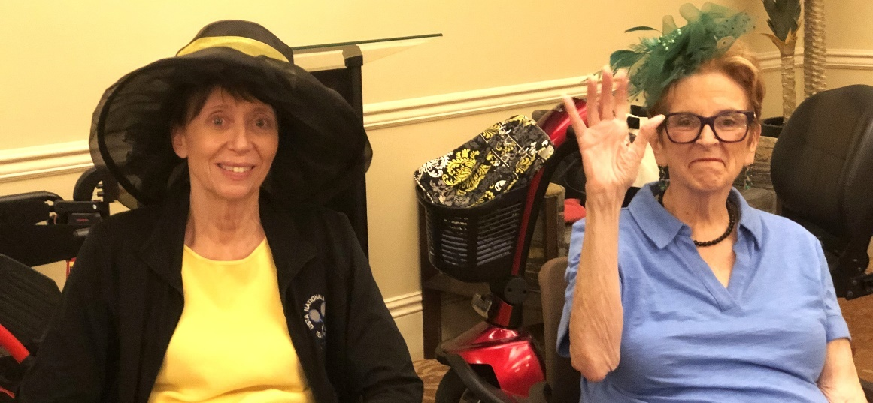
Photo by Marsha Call

The Ladies Tea by Carolyn Ruhe

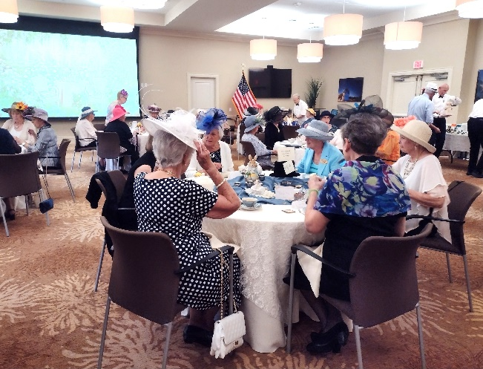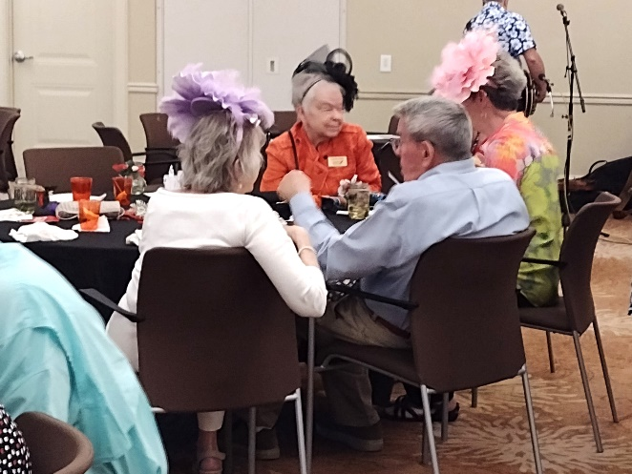

Many beautiful and glamorous hats – delightful harp music – skilled and efficient male servers – all contributed to the first tea and hats festivities on Friday, afternoon, May 3. This was one of the “kick-off” events for Derby weekend.

The auditorium was buzzing with great conversations, hats, and fancy clothes. The servers were very attentive, ensuring that the tea water was hot, that the ladies had interesting sandwiches (thank you, Taylor and Renatta), a variety of teas, sweet treats - all with a kind word and smiles!

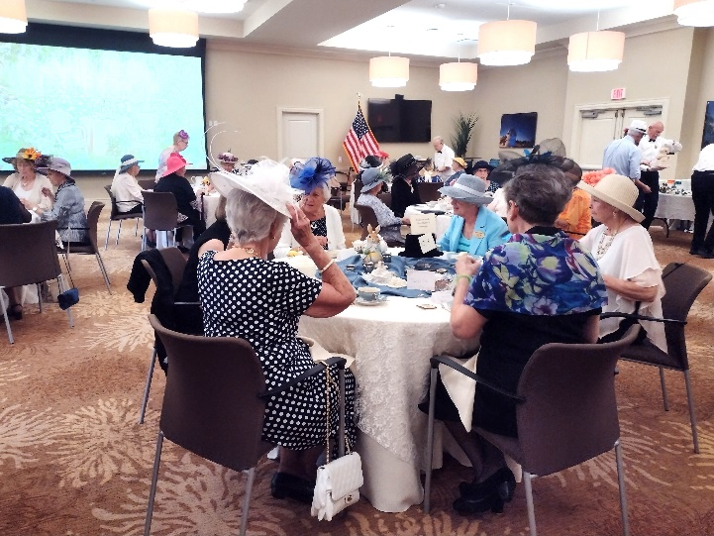
Ladies Tea in a formal setting being served by the waitstaff who were recruited by the Men at Legacy Pointe

Friends Meeting at the Ladies Tea

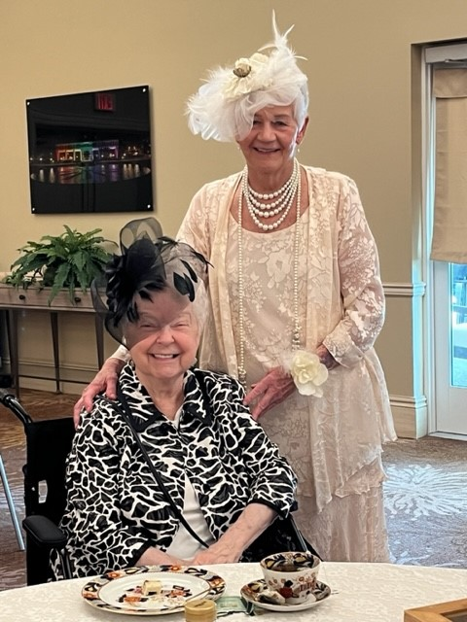

Ladies Dona & Carolyn

The ‘Heroes’ behind the scenes at the Ladies Tea

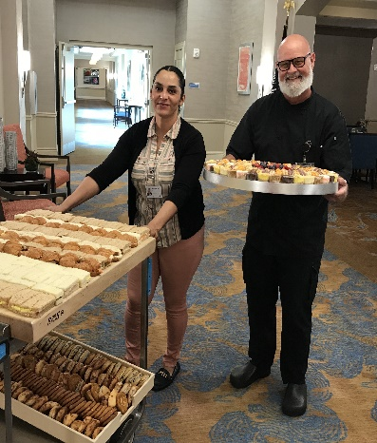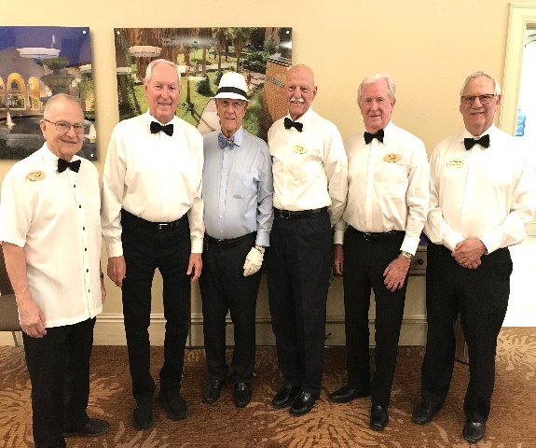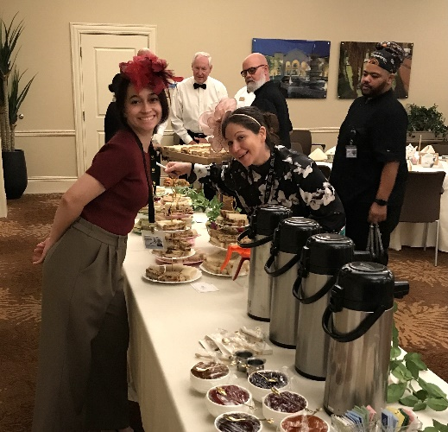

The gentlemen who volunteered to serve the ladies were: Bill Hernandez, Ross Williams, Jim Kragh, Joe Solymossy, Ed North, Les Tandler.

Thanks to everyone for a delightful afternoon.

Thank you, Christina and Bella!!

Cinco di Mayo Buffett

The Fifth of May came to L.P as part of a week that featured and afternoon of High Tea and the running of the roses at the Kentucky Derby.

To celebrate the fifth the culinary staff prepared a Sunday buffet fit for a king. Evey possible Mexican-Spanish-American dish was available to savor. The dining room was filled and very few people did not go back for seconds.

Musical Performances

Eva, Paul, and David returned for their second visit to Legacy Pointe for a musical treat on Saturday April 27th. The performance was hosted in the patio area outside of the Bistro. The music consisted of a mixture of Jazz, Pop, and Blues standards. Refreshments were provided.

NIALL DONOGHUE CONCERT
Celebrating the Birthdays
of LP Residents born in May

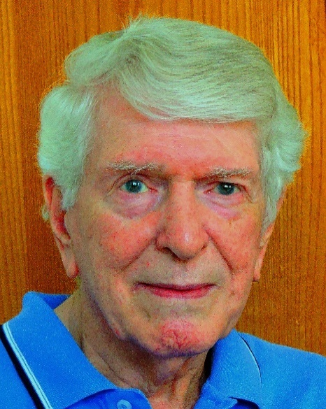

Again, for the month of May residents of Legacy Pointe who were celebrating their birthdays were treated to music and fun starring Niall Donoghue and a trio lead by Greg Parnell. The songs were familiar with a mixture of pop and jazz.
Refreshments were served to the guests.

Magic

Did someone say “MAGIC”? Yes they did and the residents of L.P. saw a magic show that they will never forget. The show featured Kostya Kimlat who is called “The Business Magician”. He is the ‘official magician for over 100 Fortune 500 companies. He is a motivational speaker, mentalist magician, and many more titles.

But he will be remembered most for his tricks – tricks that nobody could figure out. This is especially true of his last trick where 6 Legacy Pointe residents volunteered to the stage and were told to think of a country that they would like to visit. Through a series of discussion with the six, Kostya on a chalk board proceeded to write the name of each country that each resident was thinking about. Truly amazing! How did he come to L.P?

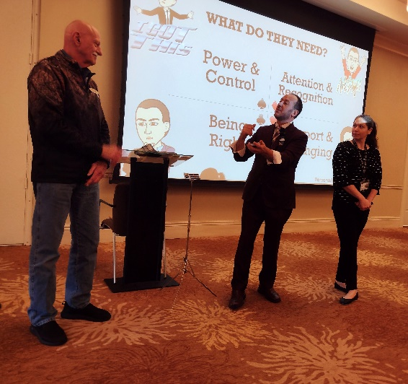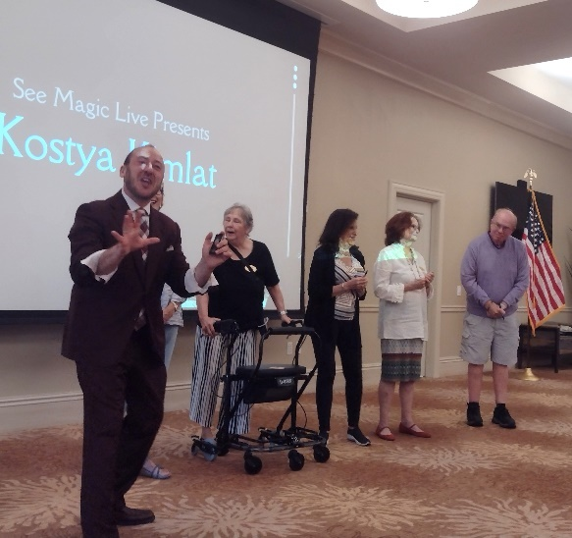

Finally, a FLAG

A little story on the flag and how it got here. Back in the Spring of 2022 soon after Legacy Pointe opened one of our residents Fred Monschein noticed LP had no flagpole or American flag. Fred was a veteran and could not believe there was no flag. He started a one-man crusade to get a pole and flag.

Fred brought his concern to the LP Men’s group which meets weekly. There is a large veteran’s membership in the group. So, the group informed the LP management that we needed to have a flag ASAP. It was agreed that not having a flag was a big oversight and needed to be addressed. It should take 45 days to get it done.

Well 45 days turned into 2 years for various reasons and finally we have a pole soon to be followed by a flag. The dedication is scheduled for Memorial Day 2024.

We are thankful to Fred starting the whole process and to all those who continued what he started. Fred will not see his flag since he died shortly after the project was started.

Below is a collage of the pole being installed. Photos by Mary Catherine Ricks


Technology
Richard Van Dyk
Richard Van Dyk found an article on the web which announces new technology called Auracast. He has written to our technology guru Joe Solymossy who is researching it.
I have come across something called Auracast. It is essentially Bluetooth, but One to Many. A single transmitter is less then $100 and would easily cover the auditorium. There are not many available yet as it is just new and I am trying to find a local user that I can talk to about it and check it out. It is being incorporated into hearing aids already and existing headphones/earbuds BT 5.2 or greater are or can be made compatible with it.
Check out the link: https://www.hearingtracker.com/auracast.
Will let you know what I find.
Richard
Joe Solymossy
On 5/9/2024 1:43 PM, Joe wrote:
During the last few months, The RC Communications Committee, Technology Subcommittee has been looking at ways technology can enhance our ways to communicate. Meanwhile the Health and Wellness Committee has been talking about using technology to enhance the hearing capabilities for individuals using hearing aids. One of those would involve the installation of a hearing loop in our auditorium. The capital planning, budgeting, approval and installation process may approve it for a 2025-2026 expenditure.
The technology class scheduled on May 21 at 2 pm will be on the use of the (New) Edge Browser, and Google Chrome Browser. In addition, I am inviting anyone who has difficulty hearing our normal presentations in the auditorium to come to this session. I especially invite all of you who have hearing enhancement implements. We are going to test the improvement in hearing in our auditorium through the use of Zoom. If you want to come to the class and test the use of Zoom, you will need a cell phone that has Bluetooth and has the Zoom application loaded on the phone. In addition, your hearing aids should be able to pair to that phone. If you are not familiar with this process, talk to me before this session. The first 15 minutes of the class we will ensure that all of you will be able to hear my presentation through your cell phone and thus directly into your hearing aids. I “read” books on audio and the sound is very crisp and clear, whereas the sound without my phone is generally not as clear. This process might be an alternate way to address some of the hearing issues.--
Have a great Day!
Joe Solymossy 321-318-2701

Look up it’s a bird; it’s a plane; it’s a Cloud
Some days it is great to look up and enjoy nature’s art.

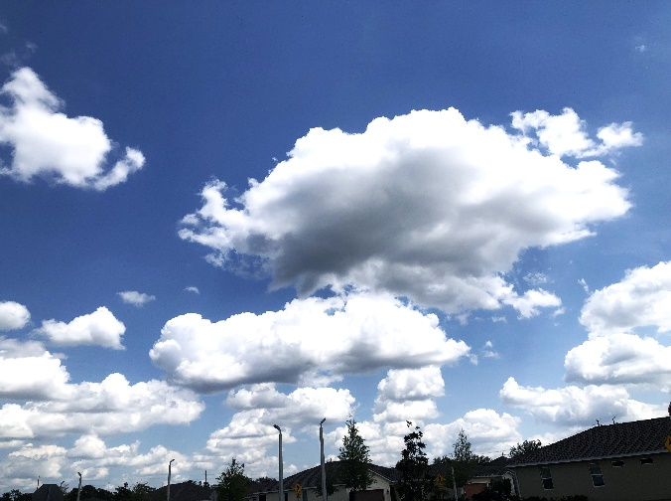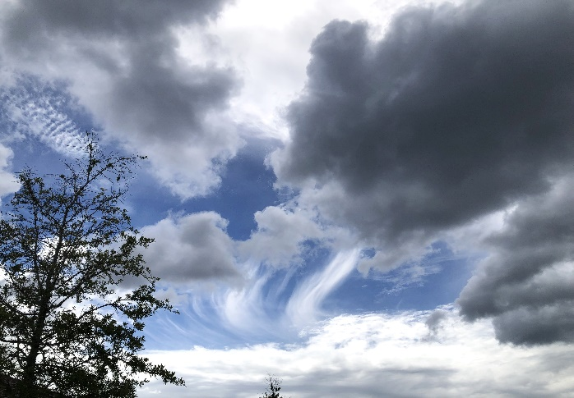

Photos by Marsha Call

The New Movie Series
Legacy Pointe movies will start up soon. The L.P. Independent Times has received an email from Bill Fernandez a member of the committee with the following schedule.
Then we start the trial run of eight (8) movie presentations in the Auditorium on Sundays at 6 pm. I have listed them below for easy clipping and posting as a reminder.
- 1st Movie Sunday: 'Queen Bees' on Sunday, May 12th @ 6 pm in the Auditorium;
- 2nd Movie Sunday: 'Brooklyn' on Sunday, May 19th @ 6 pm in the Auditorium;
- 3rd Movie Sunday: 'Midway' on Sunday, May 26th @ 6 pm in the Auditorium;
- 4th Movie Sunday: 'Dances with Wolves' on Sunday, June 2nd @ 6 pm in the Auditorium;
- 5th Movie Sunday: 'Kon Tiki' on Sunday, June 9th @ 6 pm in the Auditorium;
- 6th Movie Sunday: 'Celine Dion' Fathers Day, June 16th @ 6 pm in the Auditorium;
- 7th Movie Sunday: 'Rear Window' on Sunday, June 23rd @ 6 pm in the Auditorium;
- 8th Movie Sunday: 'Yankee Doodle Dandy' on Sunday, June 30th @ 6 pm in the Auditorium.
After conclusion of the initial eight movie presentations there will be a planned Movie Committee meeting in either the Card Room or the Bistro on Monday, July 1st at 1 pm to consider the number of attendees at "Sundays at the Movies." Then a decision will be made to either continue showing movies if enough Residents want movies and the next selections to present; OR to discontinue in the showings due to a lack of interest and low participation. If at least 10+ residents are NOT present for the movies, then this would indicate a lack of interest in showing movies and justify a decision to discontinue.

The Lifestyle Director's Office will list a brief synopsis of each movie that is to be shown so Residents/Guests will have an idea if the movies suit their tastes.

Bill Fernandez, Movie Committee Member

HEALTH AND MORE

Awareness is a Key to Good Health Research

Researched and Written by Mary Catherine Ricks

Are some of our health challenges related to certain herbicides, particularly those containing
glyphosates?

Legacy Pointe has some residents that are gluten intolerant and need to be very careful about
what they eat. Some of the symptoms include skin rashes, diarrhea, nausea, anemia and
depression. Gluten can create nutritional deficiencies that may lead to thyroid disease, kidney
failure and cancer. In recent years nutritional deficiencies have noticeably increased in the United States.

There are studies showing a possible connection between gluten intolerance and glyphosates, the active ingredient in Roundup. Farmers spray it on crops to eliminate the weed population. Fish that are exposed to glyphosate get digestive issues that create problems with gut bacteria, which is what happens with gluten intolerance.

The American company Monsanto developed glyphosates in 1974. “The German company Bayer A.G. bought Monsanto in 2018, and tens of thousands of lawsuits have been filed against the company by people claiming that Roundup and other glyphosate-based herbicides caused their cancer, especially non-Hodgkin lymphoma.”

In 2015, the part of the World Health Organization that studies cancer stated that glyphosates were “probably carcinogenic to humans.” Exposure to glyphosate-based weed killers used on lawns and sidewalks can come from inhalation, skin contact or eye exposure.

As of 2023, “Glyphosate has been or will soon be banned in at least 10 countries, including
Mexico, Germany, Saudi Arabia, and Vietnam, and at least 15 others have restricted its use,
according to Human Rights Watch. Individual cities and counties, including Los Angeles,
Seattle, Miami, Baltimore, Austin, and Portland, have taken action to restrict or ban
glyphosate, as have some states.”

Check out more by clicking on the links below:
https://www.ncbi.nlm.nih.gov/pmc/articles/PMC3945755/
https://www.webmd.com/cancer/herbicide-glyphosate-cancer

https://www.ecowatch.com/glyphosate-found-in-urine-of-93-percent-of-americans-tested-
1891146755.html

https://www.ehn.org/glyphosate-explained-2656803555/where-is-glyphosate-banned

https://www.cnn.com/2024/01/29/us/roundup-cancer-verdict-philadelphia-bayer-
monsanto/index.html


Qigong Plus Class
Qigong is an ancient Chinese method of movements and meditations done for the purpose of improving the health of the body. The word Qi means “life force energy” and gong means “practice”.

Qigong works with the 4 forms of energy: body, mind, emotions, and spirit. Thanks to Einstein, we know that “Everything is energy. Match the frequency of the reality that you want, and you cannot help but get that reality. This is physics.” Chinese Qigong Masters observed this thousands of years ago and used that to help people in their village improve their health.
On April 22, 2014, the Qigong Plus Class was started at Legacy Pointe. The class teaches breathing, movement, visualization, and meditation to help your body relax and become more peaceful. My goal is to show you how science now proves what Qigong Masters know and to make learning about your body and the universe enlightening and fun.
The class meets for an hour on Mondays at 11:00 am in the Yoga (Qigong) Studio and is limited to 18 participants. Each class is self-contained and therefore requires signing up weekly at the concierge desk. This allows more residents to participate when someone can’t attend or no longer wishes to take part. Also, please remove your name if you sign-up and find out you have a conflict.
Students are invited to bring a pencil and pad to class for taking notes. The act of physically writing information can help you retain facts that feel important to you.
Mary Catherine Ricks

Be at Peace and see a clear pattern and plan running thorough all your lives.
Nothing is by chance.

Here is another story that could be of interest in this story This article was found on MSN:
Loneliness found to increase the risk of health deterioration in older adults –
https://www.msn.com/en-us/health/other/loneliness-found-to-increase-the-risk-of-health-deterioration-in-older-adults/ar-BB1j8f8e?ocid=socialshare&pc=U531&cvid=38d8a46b8850482ce12bfe7a73cafadc&ei=22

The Knight’s Pantry

Here is a test question for your memory. If you went to college on a shoe-string budget and stayed in a dorm, do you remember how important food was to your daily nutrition? You would ‘chow down’ whenever you were invited out to eat. It would be very good for you and would definitely help to stretch the budget.
Well, the Knight’s Pantry at UCF needs your help. It offers food and other necessities to students who really need help.
One of Legacy Pointe’s residents, Mike Hynes, has been bringing donated food to the Knights pantry from us to UCF for over the past year. The collection bin is located outside the gym in the right cabinet under the credenza.
Non perishable food is accepted as well as toiletries everything from laundry detergent to personnel items.

Social, Physical, and Nutritional aspects of ‘senior living’.

For the past year this newsletter has been featuring articles each month on the Social, Physical and Nutritional aspects of Senior living. Thousands of studies have been done in each one of these areas.
This month we are going to forgo talking about the nutritional site of staying healthy and turn to some new scientific discoveries which could lead to better understanding.

One of our readers has sent in a link to an article which everyone should read who wants to stay healthy as we age. Check out the link below which our reader hopes that we are all interested.

“I thought you would be interested in this story I found on MSN: Loneliness found to increase the risk of health deterioration in older adults –“
https://www.msn.com/en-us/health/other/loneliness-found-to-increase-the-risk-of-health-deterioration-in-older-adults/ar-BB1j8f8e?ocid=socialshare&pc=U531&cvid=38d8a46b8850482ce12bfe7a73cafadc&ei=22
(hold the control key and click on the link or copy it and paste it into your browser).

DO YOU NEED TO GET OUT AND DO SOMETHING?
Check out these possibilities:

St. Luke’s Concert Series

The church meeting place was filled again. to capacity. What becomes their sanctuary for services also serves as their performance for their musical series. For the 2023 – 2024 season there were seven concerts performed. Each to that ‘full house’ crowd.

The St Luke’s season ended with the Orlando Concert Band. It was a night of ‘toe-tapping’ music plus a special performance of Rhapsody in Blue by George Gershwin. Rhapsody in Blue is a 1924 musical composition written by George Gershwin for solo piano and jazz band, which combines elements of classical music with jazz-influenced effects. The pianist was outstanding!

And amazingly the concerts are FREE!!

So, plan for next year. Below is a list of the performances for 2024 -2025.
Warning get there very early to get a great parking spot and great seats.

Save the dates for our upcoming season!
*Fall Season 2024*
*Brass Band of Central Florida*
Friday, September 12, 7PM
Saturday, September 13, 2PM
*Florida Symphony Youth Orchestra*
Saturday, October 19th, 2PM
*UCF Symphony Orchestra*
Friday, November 22nd, 7PM
*Brass Band of Central Florida*
Friday, December 6, 7PM
Saturday, December 7, 2PM
*Spring Season 2025*
*UCF Symphony Orchestra*
Saturday, February 15, 2PM
*Orlando Philharmonic Orchestra*
Friday, March 21, 7PM
*Orlando Concert Band*
Friday, April 4, 7PM

IF YOU DO NOT WANT TO GO OUT, BELOW ARE OPPORTUNITIES IF YOU STAY IN.
CHECK OUT TOUCH TOWN and then JOIN a CLUB

Check out Touch Town on your phone. There are over a dozen clubs here at Legacy Pointe that would love to have you join. Also in the Card Room there are many activities each day some starting at 7 AM

Here are just a few available The Legacy Pointe Book Club, Garden Club, Chess Club, and many others. Check Touch Town for dates and times of many others.

The Legacy Pointe Book Club meets the third Tuesday of the month at 3 PM in the Card Room

Our Book for May is called “Next Year in Havana” by Chanel Cleeton



Havana, 1958. The daughter of a sugar baron, nineteen-year-old Elisa Perez is part of Cuba's high society, where she is largely sheltered from the country's growing political unrest—until she embarks on a clandestine affair with a passionate revolutionary...
Miami, 2017. Freelance writer Marisol Ferrera grew up hearing romantic stories of Cuba from her late grandmother Elisa, who was forced to flee with her family during the revolution. Elisa's last wish was for Marisol to scatter her ashes in the country of her birth.
Arriving in Havana, Marisol comes face-to-face with the contrast of Cuba's tropical, timeless beauty and its perilous political climate. When more family history comes to light and Marisol finds herself attracted to a man with secrets of his own, she'll need the lessons of her grandmother's past to help her understand the true meaning of courage.

Our Book for June is called The Last Thing He Told Me” by Laura Dave



Before Owen Michaels disappears, he smuggles a note to his beloved wife of one year: Protect her. Despite her confusion and fear, Hannah Hall knows exactly to whom the note refers—Owen’s sixteen-year-old daughter, Bailey. Bailey, who lost her mother tragically as a child. Bailey, who wants absolutely nothing to do with her new stepmother.
As Hannah’s increasingly desperate calls to Owen go unanswered, as the FBI arrests Owen’s boss, as a US marshal and federal agents arrive at her Sausalito home unannounced, Hannah quickly realizes her husband isn’t who he said he was. And that Bailey just may hold the key to figuring out Owen’s true identity—and why he really disappeared.
Hannah and Bailey set out to discover the truth. But as they start putting together the pieces of Owen’s past, they soon realize they’re also building a new future—one neither of them could have anticipated.

SPACE LAUNCHES AT KENNEDY SPACE CENTER FOR APRIL 2024

May Launch captured over Legacy Pointe by Vicki Tindall





Photo by Joyce Swing

For list of all launches, check this website suggested by John Boldt
https://nextspaceflight.com/launches/

SURFING THE INTERNET

You could spend your whole day just sitting and surfing. If you do this your entire body will fall apart from lack of exercise. So, our newsletter is asking its readers who spend just a few minutes a day surfing to send along some links to articles that may be interesting or funny or extremely important. Send links to Frank Russo at frankrusso2012@gmail.com

How long have we or our other ancestor been around?
New discoveries are being made every day. It could be a lot longer than we think. Check out a possibility found in the Link below.
https://www.earth.com/news/476000-year-old-ancient-woodworking-discovery-rewrites-early-human-history/

Feedback? Stories? Photos?
Send to Frank Russo at frankrusso2012@gmail.com

REMEMBER sign up for the LP Residents Forum: https://lpresidentsonline.org/smf You can easily set up your login and password. The Forum is a place for you and your neighbors to come together . . . To create a knowledge base . . . To go beyond a community to becoming a family. We hope to see you online soon. If you need help, contact by email Jonathan or Ina.

"And in case you missed any issues, click the following link to access the complete Newsletter Archive:"

LP Residents Forum - Residents Newsletters (lpresidentsonline.org)

Email Jonathan at 47ipsd@gmail.com or Ina at utgrad@attglobal.net.

Our Day Ends

There goes the Sun.


By Frank Russo

Here comes the Moon.



Photo by Polly Del Vero

